Student’s name | …………………………………………………….…… | Grade | 3
Subject | Computer | Week No. | 11
Lesson Title |  | Unit
Revision Worksheet

Question A: Match the following according to their usage.

 | FOR BANKING
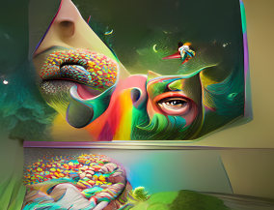 | FOR ENTERTAIMENT
 | FOR EDUCATION
 | FOR ART
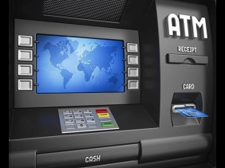 | FOR COMMUNICATION

Question B: Match the following with the correct software icons.

-  | Sketchbook
-  | Paint
-  | Calendar
-  | Gallery
-  | Notebook

Question C: Match the following according to their usage.

 | VIDEO CARD
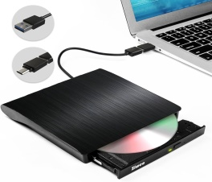 | LAPTOP BATTERY
 | CENTRAL PROCESSING UNIT
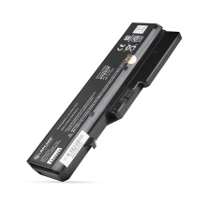 | EXTERNAL DISC
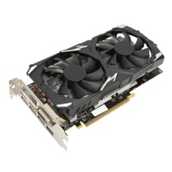 | POWER SUPPLY

Question D: State whether the below statements are True or False.

- A sprite can be an animated character.
- True b. False
- A code is used to control the action of a sprite.
- True b. False
- A stage is used to give instruction.
- True b. False
- Costumes allows us to change the color of the backdrop.
- True b. False
- Move 70 steps will move the sprite in a forward direction.
- True b. False

Question E: State whether the below statements are True or False.
Sprite Code Costumes Stage Forward

- A ___________ can be an animated character.
- A ________ is used to control the action of a sprite.
- A __________ is used to give instruction.
- __________ allows us to change the color of the backdrop.
- Move 70 steps will move the sprite in a _________ direction.

Question F: Select the correct answer from option A-C.

1.Which of the following does not belong to scratch?
a. Pencil tool b. Sprite c. Code
2. Which library allows us to choose a backdrop?
a. Pencil tool b. Sprite c. Code
3. Which option will move the sprite in a forward direction?
a. 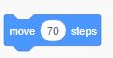 b.  c. 
4. Which option will move the sprite in a backward direction?
a.  b.  c. 
5. Which option allows us to change the colour of the backdrop?
a. 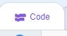 b.  c. 

Question G: Select the correct answer from option A-C.

1. Pencil tool does not belong to scratch.
a. True b. False
2. Backdrop library allows us to choose a backdrop.
a. True b. False
3. will move the sprite in a backward direction.
a. True b. False
4. will move the sprite in a forward direction.
a. True b. False
5.  allows us to change the colour of the backdrop.
a. True b. False

ANSWER KEY
Question A: Match the following according to their usage.

 | FOR BANKING
 | FOR ENTERTAIMENT
 | FOR EDUCATION
 | FOR ART
 | FOR COMMUNICATION

Question B: Match the following with the correct software icons.

-  | Sketchbook
-  | Paint
-  | Calendar
-  | Gallery
-  | Notebook

Question C: Match the following according to their usage.

 | VIDEO CARD
 | LAPTOP BATTERY
 | CENTRAL PROCESSING UNIT
 | EXTERNAL DISC
 | POWER SUPPLY

Question D: State whether the below statements are True or False.

- A sprite can be an animated character.
- True b. False
- A code is used to control the action of a sprite.
- True b. False
- A stage is used to give instruction.
- True b. False
- Costumes allows us to change the color of the backdrop.
- True b. False
- Move 70 steps will move the sprite in a forward direction.
- True b. False

Question E: State whether the below statements are True or False.
Sprite Code Costumes Stage Forward

- A Sprite can be an animated character.
- A Code is used to control the action of a sprite.
- A Code is used to give instruction.
- Costumes allows us to change the color of the backdrop.
- Move 70 steps will move the sprite in a Forward direction.

Question F: Select the correct answer from option A-C.

1.Which of the following does not belong to scratch?
a. Pencil tool b. Sprite c. Code
2. Which library allows us to choose a backdrop?
a. Pencil tool b. Sprite c. Code
3. Which option will move the sprite in a forward direction?
a.  b.  c. 
4. Which option will move the sprite in a backward direction?
a.  b.  c. 
5. Which option allows us to change the colour of the backdrop?
a.  b.  c. 

Question G: Select the correct answer from option A-C.

1. Pencil tool does not belong to scratch.
a. True b. False
2. Backdrop library allows us to choose a backdrop.
a. True b. False
3. will move the sprite in a backward direction.
a. True b. False
4. will move the sprite in a forward direction.
a. True b. False
5.  allows us to change the colour of the backdrop.
a. True b. False

